**The littoral-limnetic axis of morphometric variation in fishes: dissolved organic carbon concentration produces unexpected patterns**

Chelsea Bishop1, Kaija Gahm2, Andrew P. Hendry1, Stuart E. Jones3, Madlen Stange1, and Christopher T. Solomon2

1 Dept. of Biology, McGill University, Montréal, QC, Canada

2 Cary Institute of Ecosystem Studies, Millbrook, NY, USA

3 Dept. of Biological Sciences, University of Notre Dame, Notre Dame, IN, USA

**Abstract**

Inter- and intra-population polymorphisms in traits related to foraging and locomotion in benthic and pelagic habitats have been observed in many fishes. Benthic and pelagic food chain productivity in lakes is strongly influenced by the concentration of dissolved organic carbon (DOC) in the water, suggesting that DOC might impose selection on these traits and lead to classic benthic-foraging “littoral” forms at low DOC concentrations and pelagic-foraging “limnetic” forms at high DOC concentrations. We tested this hypothesis via geometric morphometric and meristic analyses of Bluegill sunfish (*Lepomis macrochirus*, Centrarchidae) from fourteen lakes with DOC concentrations ranging from 4 to 24 mg L-1. These lakes were located in close proximity to each other, straddling the drainage divide between the Mississippi River and Laurentian Great Lakes watersheds in northern Wisconsin, USA. Bluegill morphometry was significantly and consistently related to lake DOC concentration in both drainage basins, despite differences in morphometry between basins, with deeper bodies, shorter and smaller heads, more anterior pectoral fin insertions, and other differences in higher DOC lakes. Gill raker length and (in the Great Lakes basin) inter-raker spacing were positively related to DOC concentration, but there was no relationship between DOC and gill raker number, eye width, pectoral fin dimensions, or pectoral fin insertion angle in univariate analyses. While some traits were significantly related to DOC concentration, the directions of these relationships did not match with the predicted littoral-limnetic patterns. This may be because DOC has complex effects on the fitness landscape for foraging and locomotion traits; because high DOC favors a littoral-limentic generalist rather than a limnetic specialist; or because the littoral-limnetic morphometric dichotomy is less clear and universal than is commonly thought.

**Introduction**

Inputs of terrestrially-derived dissolved organic matter play an important role in structuring lake food webs (Jones 1992, Solomon et al. 2015, Creed et al. 2018). These inputs support heterotrophic respiration and microbial production, and bring nutrients that stimulate autotrophic production. Terrestrially-derived dissolved organic matter (measured as dissolved organic carbon, DOC) is often darkly colored, imparting a tea-stained color that reduces light penetration and changes the vertical distribution of heat. Collectively these effects have substantial implications for benthic (bottom) and pelagic (open water) food chains, including primary production of algae and secondary production of benthic and planktonic invertebrates. Benthic primary and secondary production are strongly negatively related to DOC concentration (Ask et al. 2009, Karlsson et al. 2009, Godwin et al. 2014, Craig et al. 2015). In the pelagic habitat the situation is more complex: primary production can be stimulated by intermediate DOC concentrations, though productivity falls off at high concentrations; pelagic secondary production seems to follow the same pattern (Kelly et al. 2014, Batt et al. 2015, Carpenter et al. 2016, Kelly et al. 2016, St‐Gelais et al. 2017, Kelly et al. 2018, Bergström and Karlsson 2019). Thus, benthic production is strongly negatively related, and pelagic production somewhat less strongly negatively related, to DOC concentration. These effects of DOC at the base of benthic and pelagic food chains can propagate up to influence to productivity of fishes, which often link those food chains via their mobile foraging behaviors (Vander Zanden and Vadeboncoeur 2002, Karlsson et al. 2009, Finstad et al. 2014, Craig et al. 2015, Benoit et al. 2016, Koizumi et al. 2018).

DOC concentrations can differ substantially among lakes, even those in close proximity to one another. Differences in watershed area, terrestrial vegetation, hydrologic flowpaths, lake volume, and other factors create heterogeneity in the delivery of terrestrial organic matter to lakes and its processing within lakes, and thus in the concentrations of DOC (Canham et al. 2004, Seekell et al. 2014, Jones et al. 2018). Although the DOC concentration of a given lake can vary at multiple time scales, substantial differences between lakes are fairly stable over long time periods in the absence of major anthropogenic disturbances (Jane et al. 2017, Meyer-Jacob et al. 2019).

Such spatial variation sets the stage for natural selection or phenotypic plasticity to generate adaptive variation among populations (Richardson et al. 2014). Yet we are aware of only a few studies that have considered whether fish phenotypes are related to DOC concentrations. Bartels et al. (2016), examining Eurasian Perch in lakes with DOC concentrations between 4 and 34 mg L-1, found that that increasing DOC concentration was associated with longer heads, large eyes, and narrow caudal peduncles. Several other studies considered the relationship between DOC concentration and fish growth rates or other life history traits (Benoit et al. 2016, Craig et al. 2017, van Dorst et al. 2020). For instance, Craig et al. (2017), examining Bluegill sunfish in lakes with DOC concentrations between 3 and 24 mg L-1, found that populations in lakes with high DOC had low initial growth rate, late maturity, and low lifetime fecundity, whereas these traits showed more variation among low-DOC lakes.

Given that DOC concentrations control the productivity of benthic and pelagic food chains, and differ substantially and stably between lakes, we expected that they might shape divergence in the traits of fishes that forage on either benthic or pelagic prey. Trait polymorphisms linked to the different demands of benthic and pelagic foraging have been observed in a number of fish species (Schluter and McPhail 1993, Robinson and Wilson 1994, Skulason and Smith 1995). Relative to benthic specialists, pelagic specialists tend to have fusiform bodies; longer, more numerous, and more closely spaced gill rakers; and other traits suited to sustained open water swimming and capturing small zooplankton rather than maneuvering in complex littoral habitats to capture benthic invertebrates. These environment-trait associations have been observed in many fish groups including gasterosteids, centrarchids (including Bluegill), and percids, and typically reflect a mixture of genetic differences (evolution) and environmental influences (plasticity) (Bentzen and McPhail 1984, Ehlinger and Wilson 1988, Skulason and Smith 1995, Svanbäck and Eklöv 2002).

We investigated the relationship between lake DOC concentrations and traits related to foraging in Bluegill (*Lepomis macrochirus*, Centrarchidae). Bluegill are among the most common and widespread freshwater fishes in North America, and are found in a wide range of conditions. They exhibit morphometric and behavioral polymorphisms linked to tradeoffs between benthic and pelagic foraging, as well as diverse life history strategies (Dominey 1980, Gross and Charnov 1980, Mittelbach 1981, Ehlinger and Wilson 1988, Gross 1991, Belk 1995, Aday et al. 2003). We sampled Bluegill from a set of lakes across a wide range of DOC concentrations, expecting that foraging traits of Bluegill would be consistent with a greater reliance on zooplanktivory, and lower reliance on benthivory, in high-DOC lakes. Specifically, we expected that DOC concentration would be positively associated with fusiform body shape, shorter and narrower pectoral fins inserted more anteriorly and horizontally, longer and more numerous gill rakers with smaller inter-raker spacing, and larger eyes.

**Methods**

*Study Design and Sampling*

We conducted morphometric analyses on Bluegill sampled from 14 lakes with DOC concentrations between 4 and 24 mg L-1 (Craig et al. 2017, Solomon et al. 2018, Carpenter et al. 2021; Table 1). All of the lakes were within a radius of ~30 km, roughly 100 km south of Lake Superior, near the Wisconsin-Michigan border, USA. This is a low-relief, lake-rich region that straddles the divide between the Great Lakes (Lake Superior) and Mississippi River (Wisconsin River) basins. Different lineages of Bluegill could be present on either side of the drainage divide (Kawamura et al. 2009); to minimize the risk of confounding DOC and lineage effects we chose study lakes such that our distribution of DOC concentrations and our sample size would be approximately equal in the two basins.

We took ~30 Bluegill specimens from each lake between June and August 2018, using a variety of methods including fyke nets, boat electrofishing, and angling (Table 1). Fyke nets (12 m lead, 1.3 cm bar mesh, 1 m3 car, four hoops and two throats) were set from afternoon to morning, with the lead set perpendicularly from shore. Electrofishing was conducted at night using alternating current. Angling was conducted near sunrise or sunset using standard tackle. Captured fish between 75 and 150 mm total length (or longer when necessary) were euthanized by overdose of buffered MS-222. We suspended euthanized fish from a rack by the tail before freezing them, a procedure that reduced bending and thus facilitated later geometric morphometric analysis. Animal care procedures were approved by the animal care and use committee at the Cary Institute of Ecosystem Studies under protocol #2016-06.

*Morphometrics and Meristics*

We quantified body morphometry of each specimen from a photograph by digitizing 19 true type II two-dimensional landmarks using tpsDig2 v.2.31 (Rohlf 2006) (Fig. 1A). Digital photographs were taken under consistent lighting with a Nikon D300 camera on a tripod, with the F-stop and ISO set to 15 and 200 respectively. We photographed the left side of the body after thawing the specimen, pinning its fins out (so that fin insertions were clear), ensuring that its mouth was closed, and including a scale reference. We calculated landmark measurement error following Zelditch (2012). We measured 60 fish four times each and ran a procrustes ANOVA with the following formula: procD.lm(shape ~ fishID + fishID:replicate), where ‘shape’ is the digitized landmarks from the tpsDig2 .tps output, fishID is the individual fish identifier, and replicate is the replicate number, an integer from 1 to 4. Then we used the mean square terms from the ANOVA output to compute repeatability as: R = ((MSfishID – MSfishID:replicate)/4)/(MSfishID:replicate + ((MSfishID – MSfishID:replicate)/4)).

Landmark placement was 94.7% repeatable (inter-individual variation (F = 187.1758, P = 0.001 larger than intraspecific variation (F = 2.6012, P = 0.001). Due to the high repeatability, we measured the remaining specimens only once. We calculated eye width as the distance between landmarks #2 and #19, and angle of pectoral fin insertion from landmarks #13 and #14.

After photographing each specimen we removed the right pectoral fin and preserved it in 95% ethanol. Later, we spread and pinned each fin and photographed it using the procedure described above for body photos. Four true type II 2D landmarks were digitized onto the images using tpsDig2 (Fig. 1B). Due to high variability in how far the fin could be spread apart we could not place a replicable landmark along the ventral side. This limitation prevented us from obtaining a pectoral fin width measurement, and so we instead measured fin base widths as the distance between landmarks #13 and #14 and fin length as the distance between landmarks #14 and #21. We divided the pectoral fin length by its base width to get the fin length:width ratio.

We examined the gill rakers from the left anterior-most gill arch, which we dissected from the buccal cavity. We counted the rakers under a dissecting microscope, and then took a photo of the gill arch to measure raker length and spacing. We took photos using a Leica microscope with DMC camera attachment connected via USB to a computer with Leica software. A scale reference was included in each photograph. Following Robinson et al. (1993), we measured the length of the four rakers that follow the apex raker located at the crown of the arch (Fig. 1C). For each, we measured raker length as a straight line from the insertion point in the arch to the distal point of the raker. We also measured raker spacing as a straight line along the base of arch from the posterior edge of one raker to the anterior edge of the next (total of three spaces between four rakers, Fig. 1C). These measurements were made using the measurement tool included in tpsDig2.

*Statistical Analyses*

We conducted geometric morphometrics analyses using the geomorph v.3.1.2 package in R v.4.0.3 (R Core Team 2016, Adams et al. 2019). We subjected raw coordinates to a generalized Procrustes analysis to remove isometric size effects and achieve uniform orientation (Rohlf and Slice 1990). We then conducted a principal components analysis to identify the major axes of shape variance among all the Bluegill in our sample. To visualize morphospace based on shape along the first two principal components we created a backtransformed morphospace, using both the geomorph package and the StereoMorph package (Olsen 2017). We evaluated the relationship between DOC and body shape using the random residual permutation procedure implemented in the geomorph package. Specifically, we used a multivariate analysis of covariance to describe variation in shape as a function of DOC, basin, a random lake effect, and centroid size (a proxy for fish size calculated from the 2D shape data; Klingenberg 2016).

We used univariate models to analyse phenotypic traits other than overall body shape, including pectoral fin dimensions, gill raker characteristics, and eye width. These models described variation in the trait measurement as a function of log-transformed DOC concentration, basin, and a random lake effect. Trait measurements were size standardized when necessary before models were fit (Reist 1986). We used the lmer() function from the lme4 package, version 1.1-26, to fit linear models to the log-transformed trait measurements for all traits (Bates et al. 2015). We computed conditional and marginal R2 values using the r.squaredGLMM function from the R package MuMIn, version 1.43.17 (Bartón 2020). Other packages used in analysis and plotting are dplyr (version 1.0.3, Wickham et al. 2021), ggplot2 (version 3.3.3, Wickham 2016), gridGraphics (version 0.5-1, Murrell and Wen 2020), ggtext (version 0.1.1, Wilke 2020B), and cowplot (version 1.1.1, Wilke 2020A). All data and code for our analyses are publicly available (Solomon et al. 2018; https://github.com/MFEh2o/BluegillMorphologyDataDOC).

**Results**

Body shape of Bluegill was significantly related to DOC concentration (p=<0.0001; Fig. 2). There was also a significant difference in shape between the Great Lakes and Mississippi watersheds, and a significant allometric relationship between centroid size and shape (p<0.0001). The first two principal components of the overall body shape data explained 51% of the individual-level variation in shape. Increasing values of PC1 described a shift from a longer, fusiform body to a shorter, deeper one, including from a long and narrow caudal peduncle to a short deep one; from a longer to shorter eye diameter; from a more horizontal to a more vertical insertion of the pectoral fin (Fig. 2). Increasing values of PC2 described a shift from a smaller head and more anteriorly positioned pectoral fin to a larger head and more posteriorly positioned pectoral fin (Fig. 2).

Lakes with DOC concentrations < 10 mg L-1 occupied almost the entire morphospace, whereas lakes with DOC concentrations > 10 mg L-1 were associated with positive PC1 values and negative PC2 values. Although average shapes of Great Lakes basin and Mississippi basin Bluegill were different, in both watersheds the gradient from low to high DOC was associated with higher PC1 values and lower PC2 values – that is, with deeper bodies, shorter and smaller heads, wider eyes, and pectoral fin insertions that were more anteriorly and vertically positioned.

Neither pectoral fin morphometry nor eye width was significantly related to DOC concentration, drainage basin, or their interaction in univariate analyses (Table 2, Fig. 3, Fig. 4). There was however considerable lake-level variation in these traits; the random lake effect explained 11% of the variance in pectoral fin insertion angle, 15% of the variance in pectoral fin length, and 25% of the variance in eye width (Table 2).

Gill raker morphometry was significantly related to DOC concentration and to drainage basin (Table 2, Fig. 5). Raker length was positively related to DOC concentration, and was longer in lakes in the Mississippi River drainage basin. Raker spacing was also positively related to DOC concentration, at least in the Great Lakes drainage basin; this relationship did not hold in the Mississippi River basin (Table 2, Fig. 5). The number of rakers on the gill arch ranged from 9 to 15 and was strongly related to fish size, but not to DOC or drainage basin.

**Discussion**

We observed morphological differences in Bluegill across the DOC gradient, which were largely consistent across the two major watersheds from which we sampled. Yet these differences did not neatly match our expectation of classically “benthic” traits at low DOC versus “pelagic” traits at high DOC. Instead, we observed a mixture of expected, unexpected, and null relationships between DOC concentration and the traits we examined (Table 3). We can see least two plausible explanations for these surprising results.

As a first step, it is useful to recognize that the null relationships that we observed (Table 3) probably provide evidence that DOC does not impose strong selection on these traits in Bluegill. An alternative interpretation is that DOC does impose selection on these traits but that they lack the genetic or plastic potential to respond to that selection. This second possibility does not seem likely, because studies with Pumpkinseed, a congener of Bluegill, show that most of the traits in question can have rapid plastic and/or genetic responses when fish are reared in littoral versus open water enclosures (Robinson and Wilson 1996, Yavno and Fox 2014). Hence, it seems more reasonable to conclude that DOC does not impose selection on these traits, or at least not strongly enough for us to detect it. Yet another possibility is that genetic and plastic effects offset each other, as in “counter-gradient variation” (Conover and Schultz 1995, Conover et al. 2009). Regardless, any logically consistent explanation for the results that we observed should accommodate the null relationships with DOC as well as the significant ones.

One such explanation might be that selection imposed by DOC concentration does not map neatly on to the classic littoral/limnetic axis of traits. Certainly, strong evidence exists that DOC influences the productivity of benthic and pelagic food chains, as we described in the Introduction. Yet these ecosystem-level metrics might not adequately describe the effects of DOC on either the benefits or the costs of benthic and pelagic foraging strategies, which depend on the ability to efficiently find and ingest prey while avoiding predators. For instance, Bluegill foraging in shallow waters may enjoy similar densities of zoobenthos regardless of DOC concentrations, because zoobenthos production at shallow depths can be relatively constant even as high DOC concentrations limit the range of depths at which substantial zoobenthos production occurs (Craig et al. 2015). At the same time, DOC might also influence the rate at which Bluegill can locate their prey, or be located by potential predators. High DOC concentrations can reduce the ability of fish to see zooplankton and thus the rate at which they can consume them, or interfere with the ability of zooplankton to detect chemical cues of fish presence and make a behavioral avoidance response (Estlander et al. 2010, Estlander et al. 2012, Jönsson et al. 2012, Santonja et al. 2017, Weidel et al. 2017). High DOC might also reduce the ability of piscivorous fishes to locate their prey, which could alter the predation risks that Bluegill smaller than the gape limit of the piscivore face while foraging in benthic or pelagic habitats (Ranaker et al. 2012). The unexpected trait associations that we observed – such as the trend towards deeper bodies but longer gill rakers in high DOC lakes – might reflect the net effect that DOC or other covarying factors have on the benefits and costs of benthic and pelagic foraging strategies. Future work to more carefully quantify how the benefits and costs of different foraging strategies vary across a DOC gradient would be a useful step forward from the results that we present here.

A related possibility is that high DOC concentrations might favor generalist foragers, rather than pelagic specialists as we had hypothesized. Werner and Hall (1974) developed and tested a model for the optimal diet breadth of a fish foraging on prey of different sizes available at different densities, using Bluegill as a model species. Their model considers only different size classes of *Daphnia* zooplankton as prey, allowing variation in handling time to be ignored. In the model, search time varies among prey items because prey size is linked to the distance from which it is visible. When search times overall are long – because of low prey density, poor visual conditions in the water, or low fish activity, for instance – then broader diets are favored. Interestingly, all three of these contributors to long search times might occur in high-DOC lakes, because prey densities might be low and high DOC reduces light availability and mean water column temperature (Kelly et al. 2014, Craig et al. 2015, Solomon et al. 2015). Two features of our results provide at least some support for the idea that we see generalists at high DOC. First, the mix of traits that observe in high DOC lakes does not match either of the classic limnetic or littoral morphotypes, but instead seems like a mixture of the two (Table 3). Second, the body shapes of fish from high DOC lakes tended to be fairly similar, whereas there was more divergence in morphometry among low-DOC lakes (Fig. 2). Limited pilot data on Bluegill diets in two of our study lakes (n=28 to 91 fish per lake, mean total length ~ 75 mm) also provide some support for this idea: in Crampton Lake (5.0 mg DOC L-1) fish were benthic specialists, consuming 69% benthic prey and 11% pelagic prey by mass, whereas in Hummingbird Lake (24.5 mg DOC L-1) fish consumed 45% benthic and 50% pelagic prey. This contrasts with results from stable isotope analyses of Eurasian perch, which showed nearly equal benthic and pelagic reliance at low DOC but predominantly pelagic reliance at high DOC (Bartels et al. 2016).

A second, distinct explanation for the surprising mix that we observed of expected, unexpected, and null relationships with DOC is that while the availability of benthic and pelagic prey does change with DOC in the way we had assumed, the link between benthic or pelagic foraging behavior and fish morphometry is not as strong or consistent as we had assumed, at least at an intra-species level. Certainly, there are iconic examples of littoral and limnetic morphotypes of several fish species (cites). On the other hand, exceptions exist to the expected patterns (Table 3). Some studies with *Lepomis* sunfishes (Bluegill or Pumpkinseed) provide evidence both for and against a relationship, and in some cases for relationships in opposite directions. For instance, a study of Bluegill in a single lake observed that fish collected from deep water had shorter pectoral fins than those collected from shallow vegetated habitats, while a study of Pumpkinseed collected from similar habitats in another lake observed the opposite pattern (Ehlinger and Wilson 1988, Robinson et al. 1993).

*Bluegill phylogeography*

Our observation that Bluegill from the Great Lakes and Mississippi River basins were morphologically distinct provides some interesting, albeit limited, new insight into their phylogeography. Kawamura et al. (2009) described the phylogeography of Bluegill using mitochondrial ND1 gene sequences from nearly 400 individuals sampled from the Mississippi River, Lake Michigan, and Lake Ontario basins. They concluded that the formerly-glaciated portions of these basins were recolonized, after the end of the Wisconsin glaciation 11,000 years before present, by Bluegill from two clades that diverged in the Ouachita-Ozark Highlands around 524,000 years before present. All 149 Bluegill that Kawamura et al. (2009) sampled from 5 sites in the upper Mississippi River basin had one of four closely-related haplotypes from one of these clades, while 30 of the 35 fish they sampled from three sites in the Lake Michigan basin had a single haplotype from the other clade. These results provide strong evidence that different lineages are present in the Mississippi River and Great Lakes basins. However, the study did not include any fish from the region that we studied around the drainage divide between the upper Wisconsin River and Lake Superior, nor from anywhere else in the Lake Superior basin. Our morphometric results suggest the possibility that, as in the regions sampled by Kawamura et al. (2009), different lineages may predominate on either side of the drainage divide in our study region.

*Conclusions*

While the central role of DOC in structuring lake food webs is now widely recognized, understanding of the mechanisms by which DOC influences consumer populations remains limited. Our work here adds to a growing body of literature examining the relationships between DOC and the phenotypes of fishes and other consumers (Bartels et al. 2016, Benoit et al. 2016, Craig et al. 2017, Minguez et al. 2020, van Dorst et al. 2020). At the same time, our unexpected results suggest that fully untangling the effects of DOC on phenotypes will require careful and thoughtful exploration of the multiple ways in which DOC influences the fitness landscape in lake ecosystems.

**Acknowledgements**

A. Ross helped plan and conduct sampling. This material is based upon work supported by the National Science Foundation under grant numbers 1754363, 1754561, and 1716066.

**References**

Adams, D. C., M. L. Collyer, and A. Kaliontzopoulou. 2019. Geomorph: Software for geometric morphometric analyses. R package version 3.1.2.

Aday, D., D. H. Wahl, and D. P. Phillip. 2003. Assessing population-specific and environmental influences on bluegill life histories: a common garden approach. Ecology **84**:3370-3375.

Ask, J., J. Karlsson, L. Persson, P. Ask, P. Bystrom, and M. Jansson. 2009. Terrestrial organic matter and light penetration: Effects on bacterial and primary production in lakes. Limnology and Oceanography **54**:2034-2040.

Bartels, P., P. E. Hirsch, R. Svanbäck, and P. Eklöv. 2016. Dissolved Organic Carbon Reduces Habitat Coupling by Top Predators in Lake Ecosystems. Ecosystems:1-13.

Kamil Bartoń (2020). MuMIn: Multi-Model Inference. R package version 1.43.17.

https://CRAN.R-project.org/package=MuMIn

Bates, D., M. Maechler, B. Bolker, and S. Walker. 2015. Fitting Linear Mixed-Effects Models Using lme4. Journal of Statistical Software **67**:1-48.

Batt, R. D., S. R. Carpenter, J. J. Cole, M. L. Pace, R. A. Johnson, J. T. Kurtzweil, and G. M. Wilkinson. 2015. Altered energy flow in the food web of an experimentally darkened lake. Ecosphere **6**.

Belk, M. C. 1995. Variation in growth and age at maturity in bluegill sunfish - genetic or environmental effects? Journal of Fish Biology **47**:237-247.

Benoit, P. O., B. E. Beisner, and C. T. Solomon. 2016. Growth rate and abundance of common fishes is negatively related to dissolved organic carbon concentration in lakes. Canadian Journal of Fisheries and Aquatic Sciences **73**:1230-1236.

Bentzen, P., and J. McPhail. 1984. Ecology and evolution of sympatric sticklebacks (Gasterosteus): specialization for alternative trophic niches in the Enos Lake species pair. Canadian Journal of Zoology **62**:2280-2286.

Bergström, A.-K., and J. Karlsson. 2019. Light and nutrient control phytoplankton biomass responses to global change in northern lakes. Global Change Biology **25**:2021-2029.

Canham, C. D., M. L. Pace, M. J. Papaik, A. G. B. Primack, K. M. Roy, R. J. Maranger, R. P. Curran, and D. M. Spada. 2004. A spatially explicit watershed-scale analysis of dissolved organic carbon in Adirondack lakes. Ecological Applications **14**:839-854.

Carpenter, S., J. Kitchell, T. Kratz, and J. Magnuson. 2021. Biocomplexity at North Temperate Lakes LTER; Coordinated Field Studies: Chemical Limnology 2001 - 2004. Environmental Data Initiative.

Carpenter, S. R., J. J. Cole, M. L. Pace, and G. M. Wilkinson. 2016. Response of plankton to nutrients, planktivory and terrestrial organic matter: a model analysis of whole‐lake experiments. Ecology Letters **19**:230-239.

Conover, D. O., T. A. Duffy, and L. A. Hice. 2009. The covariance between genetic and environmental inﬂuences across ecological gradients. Ann. NY Acad. Sci. **1168**:100.

Conover, D. O., and E. T. Schultz. 1995. Phenotypic similarity and the evolutionary significance of countergradient variation. Trends in Ecology & Evolution **10**:248-252.

Craig, N., S. E. Jones, B. C. Weidel, and C. T. Solomon. 2015. Habitat, not resource availability, limits consumer production in lake ecosystems. Limnology and Oceanography **60**:2079-2089.

Craig, N., S. E. Jones, B. C. Weidel, and C. T. Solomon. 2017. Life history constraints explain negative relationship between fish productivity and dissolved organic carbon in lakes. Ecology and Evolution **7**:6201-6209.

Creed, I. F., A.-K. Bergström, C. G. Trick, N. B. Grimm, D. O. Hessen, J. Karlsson, K. A. Kidd, E. Kritzberg, D. M. McKnight, E. C. Freeman, O. E. Senar, A. Andersson, J. Ask, M. Berggren, M. Cherif, R. Giesler, E. R. Hotchkiss, P. Kortelainen, M. M. Palta, T. Vrede, and G. A. Weyhenmeyer. 2018. Global change-driven effects on dissolved organic matter composition: Implications for food webs of northern lakes. Global Change Biology **24**:3692-3714.

Dominey, W. J. 1980. Female mimicry in male bluegill sunfish - a genetic polymorphism. Nature **284**:546-548.

Ehlinger, T. J., and D. S. Wilson. 1988. Complex foraging polymorphism in bluegill sunfish. Proceedings of the National Academy of Sciences of the United States of America **85**:1878-1882.

Estlander, S., J. Horppila, M. Olin, M. Vinni, H. Lehtonen, M. Rask, and L. Nurminen. 2012. Troubled by the humics—effects of water colour and interspecific competition on the feeding efficiency of planktivorous perch.

Estlander, S., L. Nurminen, M. Olin, M. Vinni, S. Immonen, M. Rask, J. Ruuhijarvi, J. Horppila, and H. Lehtonen. 2010. Diet shifts and food selection of perch Perca fluviatilis and roach Rutilus rutilus in humic lakes of varying water colour. Journal of Fish Biology **77**:241-256.

Finstad, A. G., I. P. Helland, O. Ugedal, T. Hesthagen, and D. O. Hessen. 2014. Unimodal response of fish yield to dissolved organic carbon. Ecology Letters **17**:36-43.

Godwin, S. C., S. E. Jones, B. C. Weidel, and C. T. Solomon. 2014. Dissolved organic carbon concentration controls benthic primary production: Results from in situ chambers in north‐temperate lakes. Limnology and Oceanography **59**:2112-2120.

Gross, M. R. 1991. Evolution of alternative reproductive strategies: frequency-dependent sexual selection in male bluegill sunfish. Philosophical Transactions of the Royal Society B: Biological Sciences **332**:59-66.

Gross, M. R., and E. L. Charnov. 1980. Alternative male life histories in bluegill sunfish. Proceedings of the National Academy of Sciences of the United States of America-Biological Sciences **77**:6937-6940.

Jane, S. F., L. A. Winslow, C. K. Remucal, and K. C. Rose. 2017. Long-term trends and synchrony in dissolved organic matter characteristics in Wisconsin, USA, lakes: Quality, not quantity, is highly sensitive to climate. Journal of Geophysical Research: Biogeosciences **122**:546-561.

Jones, R. I. 1992. The influence of humic substances on lacustrine planktonic food-chains. Hydrobiologia **229**:73-91.

Jones, S. E., J. A. Zwart, P. T. Kelly, and C. T. Solomon. 2018. Hydrologic context constrains lake heterotrophy and terrestrial carbon fate. Limnology and Oceanography Letters **3**:256-264.

Jönsson, M., L. Ranåker, P. Anders Nilsson, and C. Brönmark. 2012. Prey‐type‐dependent foraging of young‐of‐the‐year fish in turbid and humic environments. Ecology of Freshwater Fish **21**:461-468.

Karlsson, J., P. Bystrom, J. Ask, P. Ask, L. Persson, and M. Jansson. 2009. Light limitation of nutrient-poor lake ecosystems. Nature **460**:506-509.

Kawamura, K., R. Yonekura, O. Katano, Y. Taniguchi, and K. Saitoh. 2009. Phylogeography of the Bluegill Sunfish, *Lepomis macrochirus*, in the Mississippi River Basin. Zoological Science **26**:24-34, 11.

Kelly, P. T., N. Craig, C. T. Solomon, B. C. Weidel, J. A. Zwart, and S. E. Jones. 2016. Experimental whole-lake increase of dissolved organic carbon concentration produces unexpected increase in crustacean zooplankton density. Global Change Biology **22**:2766-2775.

Kelly, P. T., C. T. Solomon, B. C. Weidel, and S. E. Jones. 2014. Terrestrial carbon is a resource, but not a subsidy, for lake zooplankton. Ecology **95**:1236-1242.

Kelly, P. T., C. T. Solomon, J. A. Zwart, and S. E. Jones. 2018. A framework for understanding variation in pelagic gross primary production of lake ecosystems. Ecosystems **21**:1364-1376.

Klingenberg, C. P. 2016. Size, shape, and form: concepts of allometry in geometric morphometrics. Development genes and evolution **226**:113-137.

Koizumi, S., N. Craig, J. A. Zwart, P. T. Kelly, J. P. Ziegler, B. C. Weidel, S. E. Jones, and C. T. Solomon. 2018. Experimental whole-lake dissolved organic carbon increase alters fish diet and density but not growth or productivity. Canadian Journal of Fisheries and Aquatic Sciences.

McPhail, J. D. 1984. Ecology and evolution of sympatric sticklebacks (Gasterosteus): morphological and genetic evidence for a species pair in Enos Lake, British Columbia. Canadian Journal of Zoology **62**:1402-1408.

Meyer-Jacob, C., N. Michelutti, A. M. Paterson, B. F. Cumming, W. B. Keller, and J. P. Smol. 2019. The browning and re-browning of lakes: Divergent lake-water organic carbon trends linked to acid deposition and climate change. Scientific Reports **9**:1-10.

Minguez, L., E. Sperfeld, S. A. Berger, J. C. Nejstgaard, and M. O. Gessner. 2020. Changes in food characteristics reveal indirect effects of lake browning on zooplankton performance. Limnology and Oceanography **65**:1028-1040.

Mittelbach, G. G. 1981. Foraging efficiency and body size: a study of optimal diet and habitat use by bluegills. Ecology **62**:1370-1386.

Olsen, A. M. 2017. Feeding ecology is the primary driver of beak shape diversification in waterfowl. Functional Ecology **31**:1985-1995.

Olsen, AM & A Haber (2017). StereoMorph: Stereo Camera Calibration and Reconstruction. Version

1.6.3. https://CRAN.R-project.org/package=StereoMorph

R Core Team. 2016. R: A language and environment for statistical computing. R Foundation for Statistical Computing, Vienna, Austria.

Ranaker, L., M. Jonsson, P. A. Nilsson, and C. Bronmark. 2012. Effects of brown and turbid water on piscivore-prey fish interactions along a visibility gradient. Freshwater Biology **57**:1761-1768.

Reist, J. D. 1986. An empirical evaluation of coefficients used in residual and allometric adjustment of size covariation. Canadian Journal of Zoology **64**:1363-1368.

Richardson, J. L., M. C. Urban, D. I. Bolnick, and D. K. Skelly. 2014. Microgeographic adaptation and the spatial scale of evolution. Trends in Ecology & Evolution **29**:165-176.

Robinson, B. W., and D. S. Wilson. 1994. Character Release and Displacement in Fishes: A Neglected Literature. The American Naturalist **144**:596-627.

Robinson, B. W., and D. S. Wilson. 1996. Genetic variation and phenotypic plasticity in a trophically polymorphic population of pumpkinseed sunfish (Lepomis gibbosus). Evolutionary Ecology **10**:631-652.

Robinson, B. W., D. S. Wilson, A. S. Margosian, and P. T. Lotito. 1993. Ecological and morphological differentiation of pumpkinseed sunfish in lakes without bluegill sunfish. Evolutionary Ecology **7**:451-464.

Rohlf, F. J. 2006. tpsDig2, digitize landmarks and outlines. Department of Ecology and Evolution, State University of New York Stony Brook, Stony Brook, NY.

Rohlf, F. J., and D. Slice. 1990. Extensions of the Procrustes method for the optimal superimposition of landmarks. Systematic biology **39**:40-59.

Santonja, M., L. Minguez, M. O. Gessner, and E. Sperfeld. 2017. Predator–prey interactions in a changing world: humic stress disrupts predator threat evasion in copepods. Oecologia **183**:887-898.

Schluter, D., and J. D. McPhail. 1993. Character displacement and replicate adaptive radiation. Trends in Ecology & Evolution **8**:197-200.

Seekell, D. A., J.-F. Lapierre, M. L. Pace, C. Gudasz, S. Sobek, and L. J. Tranvik. 2014. Regional-scale variation of dissolved organic carbon concentrations in Swedish lakes. Limnology and Oceanography **59**:1612-1620.

Skulason, S., and T. B. Smith. 1995. Resource polymorphisms in vertebrates. Trends in Ecology & Evolution **10**:366-370.

Solomon, C., S. Jones, B. Weidel, B. Bertolet, C. Bishop, J. Coloso, N. Craig, C. Dassow, S. Koizumi, C. Olson, A. Ross, K. Saunders, W. West, J. Ziegler, and J. Zwart. 2018. MFE database: Data from ecosystem ecology research by Jones, Solomon, and collaborators on the ecology and biogeochemistry of lakes and lake organisms in the Upper Midwest, USA. figshare.

Solomon, C. T., S. E. Jones, B. C. Weidel, I. Buffam, M. L. Fork, J. Karlsson, S. Larsen, J. T. Lennon, J. S. Read, S. Sadro, and J. E. Saros. 2015. Ecosystem consequences of of changing inputs of terrestrial dissolved organic matter to lakes: current knowledge and future challenges. Ecosystems **18**:376-389.

St‐Gelais, N. F., A. R. Sastri, P. A. del Giorgio, and B. E. Beisner. 2017. Magnitude and regulation of zooplankton community production across boreal lakes. Limnology and Oceanography Letters **2**:210-217.

Svanbäck, R., and P. Eklöv. 2002. Effects of habitat and food resources on morphology and ontogenetic growth trajectories in perch. Oecologia **131**:61-70.

van Dorst, R. M., A. Gårdmark, R. Svanbäck, and M. Huss. 2020. Does browning-induced light limitation reduce fish body growth through shifts in prey composition or reduced foraging rates? Freshwater Biology **65**:947-959.

Vander Zanden, M. J., and Y. Vadeboncoeur. 2002. Fishes as integrators of benthic and pelagic food webs in lakes. Ecology **83**:2152-2161.

Webb, P. W. 1982. Locomotor Patterns in the Evolution of Actinopterygian Fishes. American Zoologist **22**:329-342.

Weidel, B. C., K. Baglini, S. E. Jones, P. T. Kelly, C. T. Solomon, and J. A. Zwart. 2017. Light climate and dissolved organic carbon concentration influence species-specific changes in fish zooplanktivory. Inland Waters **7**:210-217.

Werner, E. E., and D. J. Hall. 1974. Optimal foraging and size selection of prey by bluegill sunfish (Lepomis macrochirus). Ecology **55**:1042-1052.

Yavno, S., and M. Fox. 2014. Morphological plasticity of native and non-native pumpkinseed sunfish in response to habitat type. Evolutionary Ecology Research **16**:373-395.

Zelditch, M., Swiderski, D. L., & Sheets, H. D. (2012). *Geometric Morphometrics for Biologists: A Primer* (2nd ed.). Elsevier/AP.

**Table 1**. Summary of lake characteristics and sampling for survey lakes. DOC is dissolved organic carbon concentration.

|  |  |  |  |  |  |  |  |  |
| --- | --- | --- | --- | --- | --- | --- | --- | --- |
| Lake | Latitude | Longitude | Area (ha) | Max depth (m) | DOC (mg/L) | Basin | # fish collected | Capture method(s)* |
| Bay | 46.24418 | -89.49733 | 67 | 12.2 | 7.4 | Great Lakes | 30 | FN, A |
| Birch | 46.21767 | -89.83838 | 205 | 13.7 | 10.9 | Mississippi | 29 | FN, E |
| Crampton | 46.20965 | -89.47368 | 26 | 18.5 | 5.0 | Great Lakes | 30 | FN |
| Found | 45.95051 | -89.45320 | 136 | 6.4 | 6.2 | Mississippi | 30 | E |
| Hummingbird | 46.24368 | -89.50587 | 1 | 7.6 | 24.5 | Great Lakes | 30 | FN, A |
| Little Crooked | 46.15085 | -89.69511 | 62 | 9.1 | 4.1 | Mississippi | 30 | E |
| Lost | 45.96554 | -89.48312 | 218 | 6.1 | 4.0 | Mississippi | 30 | FN, E |
| McCullough | 46.19831 | -89.57043 | 89 | 8.2 | 14.3 | Great Lakes | 30 | FN |
| Muskellunge | 45.95180 | -89.37989 | 109 | 5.8 | 6.7 | Mississippi | 30 | E |
| Oxbow | 46.19967 | -89.49964 | 212 | 13.4 | 11.1 | Great Lakes | 30 | FN, E |
| Papoose | 46.18476 | -89.80266 | 171 | 19.8 | 6.5 | Mississippi | 30 | FN |
| Red Bass | 46.19825 | -89.66405 | 11 | 6.7 | 18.9 | Great Lakes | 30 | FN |
| Squaw | 45.88447 | -89.99458 | 298 | 6.4 | 21.6 | Mississippi | 28 | FN |
| Towanda | 45.93854 | -89.70771 | 56 | 8.2 | 5.3 | Mississippi | 30 | FN, E |

*FN= fyke-net, A= angling, E= electrofishing.

**Table 2**. Summary of mixed effects models describing the relationships between lake dissolved organic carbon concentration (DOC) and the eye, gill raker, and pectoral fin morphometry of Bluegill. Each column summarizes a univariate model for the log-transformed response variable indicated in the column header; all response variables except for gill raker count were size-standardized prior to log transformation. Data in the first four rows are the restricted maximum likelihood point estimates (and likelihood profile 95% confidence intervals) for the fixed effects, including and intercept, DOC, drainage basin in which the lake is located (0 for Great Lakes basin, 1 for Mississippi River basin), and the interaction between DOC and basin. Effects for which the confidence interval does not include zero are highlighted in bold. The slake and sresidual rows give the point estimates for the standard deviations of the random lake effect and the residuals. R2marginal is the proportion of the variance described by the fixed effects in the model, and R2conditional is the proportion of the variance described by the full model including the random effects; both R2 values were computed using the r.squaredGLMM function in the package MuMIn, version 1.43.17 (Bartón 2020).

|  |  |  |  |  |  |  |  |  |
| --- | --- | --- | --- | --- | --- | --- | --- | --- |
|  | pectoral fin  length | pectoral fin  width | pectoral fin length:width | pectoral fin  insertion angle | eye  width | raker  length | raker  spacing | raker  count |
| intercept | **3.34 (1.55, 1.92)** | **1.73 (1.55, 1.92)** | **1.61 (1.40, 1.83)** | **4.04 (3.84, 4.25)** | **2.22 (2.09, 2.36)** | **2.50 (2.28, 2.72)** | **1.75 (1.57, 1.93)** | **2.45 (2.31, 2.59)** |
| log(DOC) | 0.07 (-0.03, 0.11) | 0.04 (-0.03, 0.11) | 0.02 (-0.06, 0.10) | 0.04 (-0.04, 0.13) | -0.01 (-0.07, 0.04) | **0.21 (0.12, 0.30)** | **0.11 (0.04, 0.18)** | -0.01 (-0.01, 0.04) |
| basin | 0.26 (-0.07, 0.38) | 0.16 (-0.07, 0.38) | 0.09 (-0.18, 0.35) | 0.07 (-0.18, 0.32) | 0.01 (-0.15, 0.18) | **0.35 (0.08, 0.62)** | 0.20 (-0.02, 0.42) | 0.05 (-0.13, 0.22) |
| log(DOC):basin | -0.11 (-0.17, 0.02) | -0.07 (-0.17, 0.02) | -0.03 (-0.14, 0.08) | 0.01 (-0.09, 0.12) | -0.0006 (-0.07, 0.07) | -0.11 (-0.23, 0.003) | **-0.10 (-0.19, -0.002)** | -0.03 (-0.11, 0.04) |
| slake | 0.04 | 0.04 | 0.05 | 0.05 | 0.04 | 0.06 | 0.04 | 0.04 |
| sresidual | 0.11 | 0.15 | 0.12 | 0.15 | 0.05 | 0.15 | 0.16 | 0.11 |
| R2marginal | 0.06 | 0.01 | 0.01 | 0.08 | 0.03 | 0.22 | 0.08 | 0.02 |
| R2conditional | 0.21 | 0.06 | 0.16 | 0.19 | 0.38 | 0.32 | 0.15 | 0.13 |

**Table 3.** Summary of the expected and observed relationships between fish morphometry and lake dissolved organic carbon concentration (DOC). Numbers in brackets refer to citations listed in the footnotes. *Expectation* is the expected relationship. *Opposing evidence* highlights studies that counter the expectation. *Observed (morphospace)* is the trend that we observed in the multivariate analysis of external morphometry (Fig. 2). In this column and the next one **bold** indicates that the observation matched the expectation, while *italics* indicate that the observation showed the reverse of the expected pattern. Traits not considered in a given analysis are indicated with a dash (-). *Observed (univariate)* summarizes the result of a univariate test of significance of the relationship between the trait and DOC concentration. In all columns, table entries indicate the morphometry associated with high-DOC lakes; for instance, body shape was expected to be more fusiform in high-DOC lakes (and therefore less fusiform, or more deep, in low-DOC lakes).

|  |  |  |  |  |
| --- | --- | --- | --- | --- |
| **Trait** | **Expectation** | **Opposing evidence** | **Observed**  **(morphospace)** | **Observed**  **(univariate)** |
| Body shape | fusiform [1, 2, 3] | no relationship [4*] | *deep* | - |
| Caudal peduncle depth | shallow [5, 6] | no relationship [4*] | *deep* | - |
| Caudal peduncle length | long [3, 4] |  | *short* | - |
| Head length | long [6, 7] | [4*] | *short* | - |
| Head depth | shallow [7] |  | **shallow** | - |
| Eye size | large [6, 7] |  | **large** | no relationship |
| Pectoral fin insertion point | anterior [1] |  | **anterior** | - |
| Pectoral fin insertion angle | horizontal [1] | no relationship [4] | vertical | no relationship |
| Pectoral fin length | short [1,3] | long [4] | - | no relationship |
| Pectoral fin width | narrow |  | no relationship | no relationship |
| Gill raker length | long [8] |  | - | **long** |
| Gill raker spacing | narrow [2] | no relationship [4*] | - | *wide;* no relationship** |
| Gill raker number | more [2] | no relationship [4*] | - | no relationship |

[1] Ehlinger and Wilson (1988); [2] Robinson and Wilson (1994); [3] Svanbäck and Eklöv (2002); [4] Robinson et al. (1993); [5] Webb (1982); [6] Bartels et al. (2016); [7] McPhail (1984); [8] Schluter and McPhail (1993).

* This study examined littoral and pelagic forms of pumpkinseed in a lake without Bluegill. Pelagic fish had (non-significant) shallower bodies and caudal peduncles. There was no difference in number of gill rakers or gill raker length, but rakers were wider and angled differently in pelagic form, such that they overlapped more. Head length measured as predorsal length was shorter in pelagic fish; for other measures of head length there was a significant interaction between habitat (benthic or pelagic) and fish size.

** Gill raker spacing was positively related to DOC in the Great Lakes basin, but not in the Mississippi River basin.

**Figure 1**

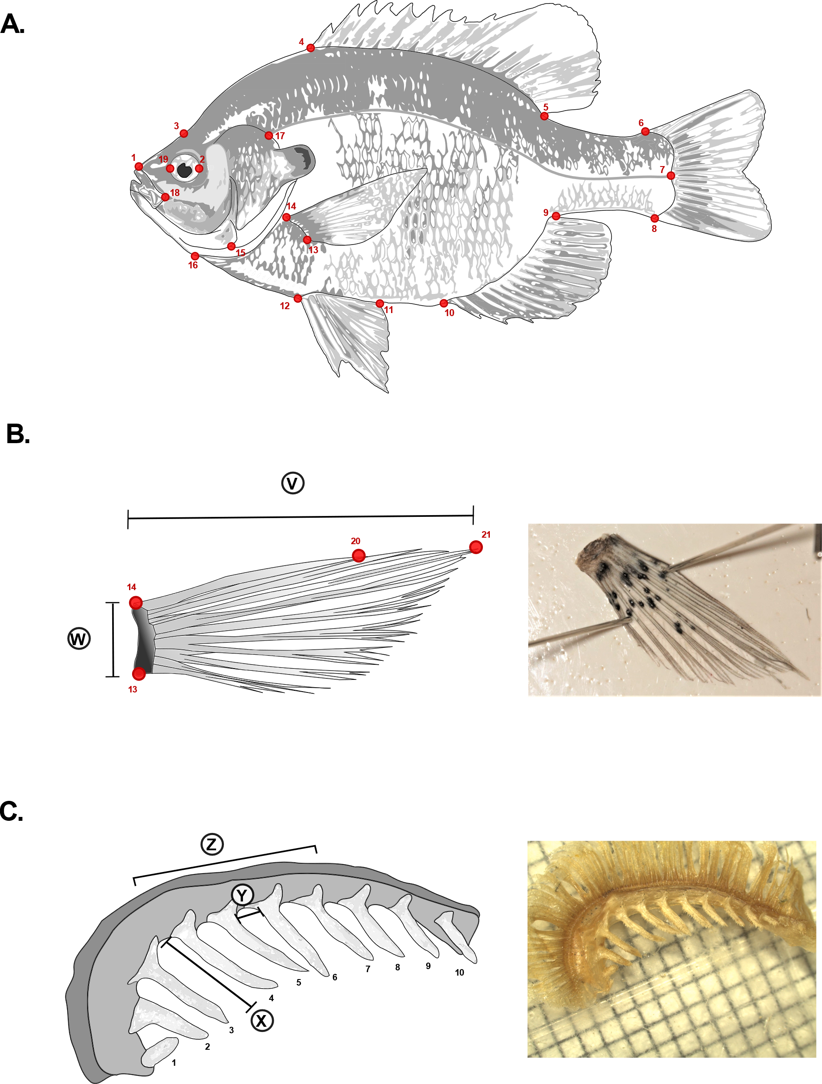

**Figure 1.** Landmark positions and meristic measurements for Bluegill sunfish**. A.** Full body landmark positions**. 1.** Dorsal tip of premaxillary. **2**. Right-centered edge of eye. **3.** Forehead above center of eye. **4**. Dorsal fin anterior insertion point. **5**. Dorsal fin posterior insertion point. **6**. Caudal fin dorsal insertion point. **7**. Caudal fin mid insertion point intersecting with lateral line end point. **8**. Caudal fin ventral insertion point. **9**. Anal fin posterior insertion point**. 10**. Anal fin anterior insertion point. **11**. Pelvic fin posterior insertion point. **12**. Pelvic fin anterior insertion point. **13**. Pectoral fin ventral insertion point. **14**. Pectoral fin dorsal insertion point**. 15.** Intersection point between suboperculum and interoperculum**. 16.** Anterior intersection point between isthmus and gill structures. **17**. Intersection point between lateral line and operculum. **18.** Dorsal, posterior tip of maxillary. **19**. Left-centered edge of eye. **B.** Pectoral fin landmarks and measurements. **20**. Tip of first dorsal ray. **21**. Tip of third/longest ray. **V**. Fin length measurement. **W**. Fin base width measurement. **C**. Gill arch with raker measurements. **X**. Raker length measurement. **Y**. Raker spacing measurement. **Z**. Rakers 4-7 and spaces between them were those used in analyses. Image of Bluegill is adapted from illustration by Duane Raver, US Fish and Wildlife Service website.

**Figure 2**

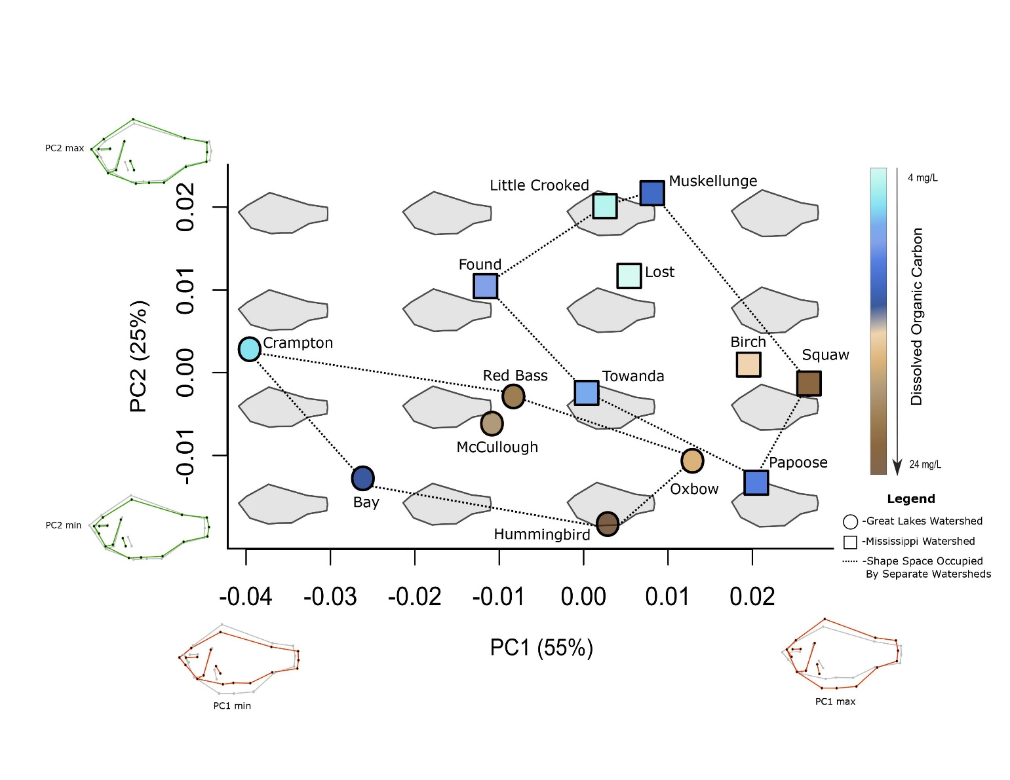**Figure 2.** Variation in Bluegill shape across lakes is related to dissolved organic carbon (DOC) concentration. Points indicate the mean fish shape from each lake; point shape indicates the basin in which the lake is located and point color indicates its DOC concentration. Fish shapes are plotted in the background for reference. PC1 is positively correlated with shorter, deeper body shape, a more vertical pectoral fin insertion angle and a smaller eye diameter. PC2 is positively correlated with head size and a more posteriorly pectoral fin position.

**Figure 3**

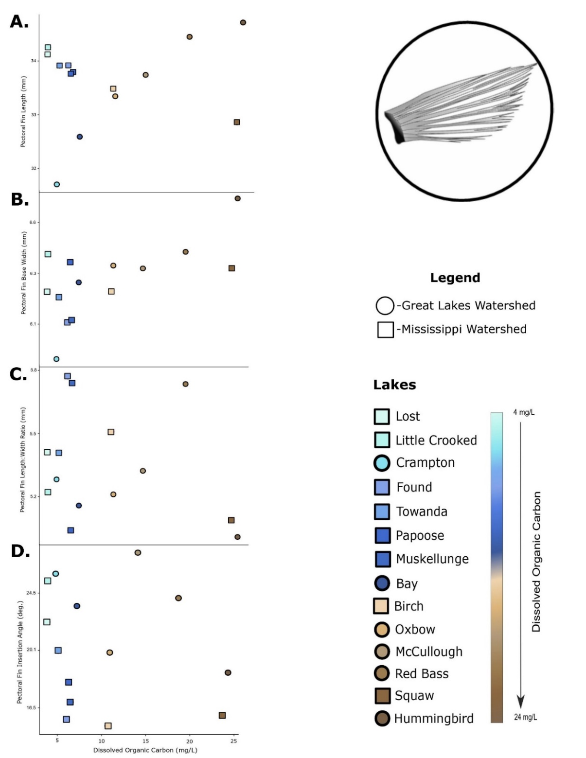

**Figure 3**. Pectoral fin length (A), width at base (B), length:width ratio (C), and insertion angle (D) of Bluegill sunfish in lakes with different dissolved organic carbon (DOC) concentrations. Points indicate the fitted, size-corrected mean value for each lake. Point shape and color indicate the drainage basin and DOC concentration of the lake.

**Figure 4**

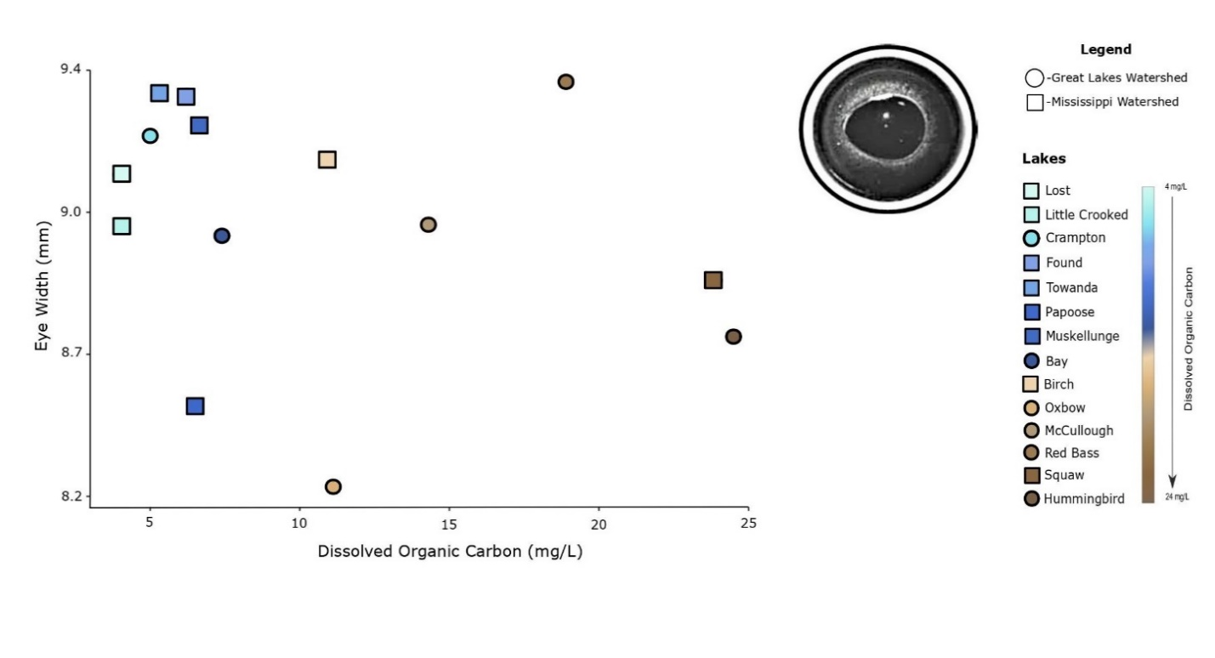**Figure 4.** Eye width of Bluegill sunfish in lakes with different dissolved organic carbon (DOC) concentrations. Points indicate the fitted, size-corrected mean value for each lake. Point shape and color indicate the drainage basin and DOC concentration of the lake.

**Figure 5**

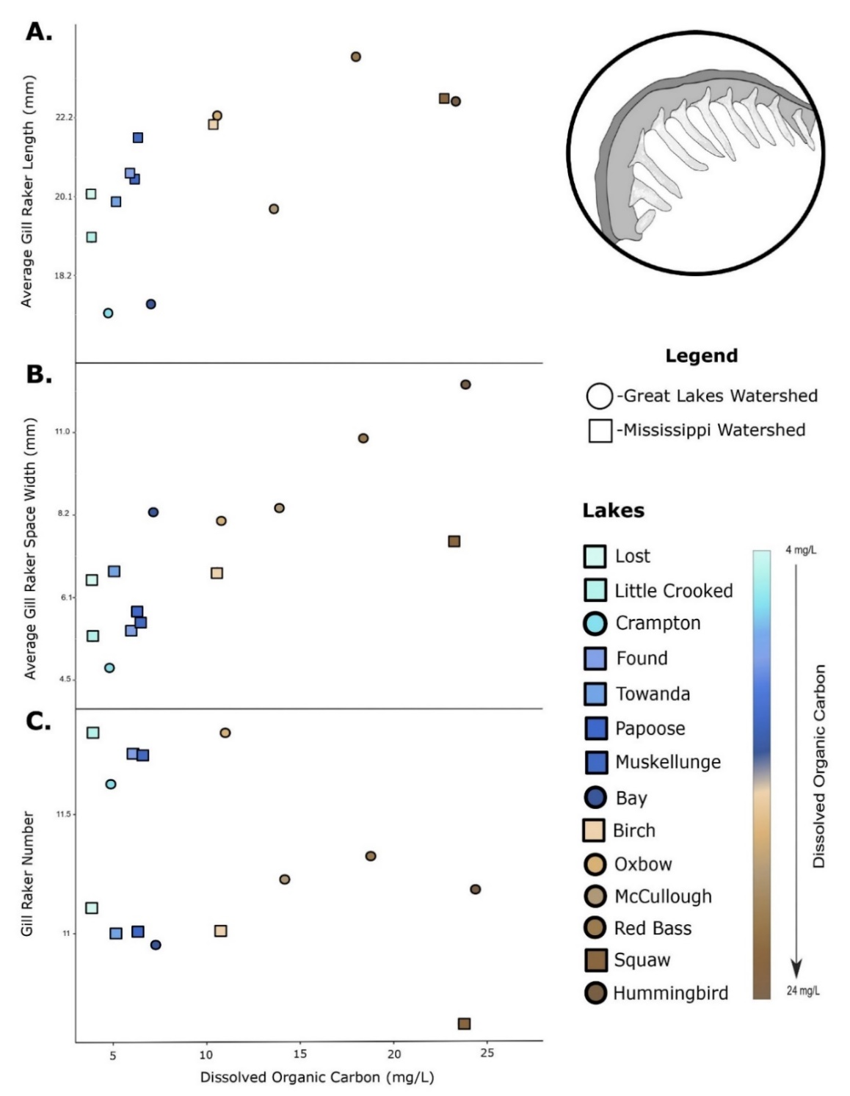

**Figure 5.** Gill raker length (A), spacing between gill rakers (B), and number of gill rakers (C) of Bluegill sunfish in lakes with different dissolved organic carbon (DOC) concentrations. Points indicate the fitted, size-corrected mean value for each lake. Point shape and color indicate the drainage basin and DOC concentration of the lake.